Introduction to Quantum Computing

Bloch sphere worksheet

Here are some blank Bloch Spheres for representing qubits. Place a dot where you think the value should be. Put in a value where you see a dot.
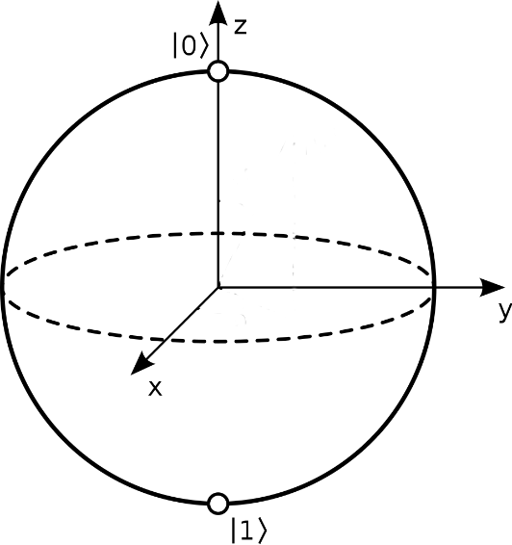
Value = |1>  Where is the blue dot? | Value = |0>  Where is the blue dot?
Value = |0.5>  Where is the blue dot? | Value = |0.5>  Can the blue dot be somewhere different?
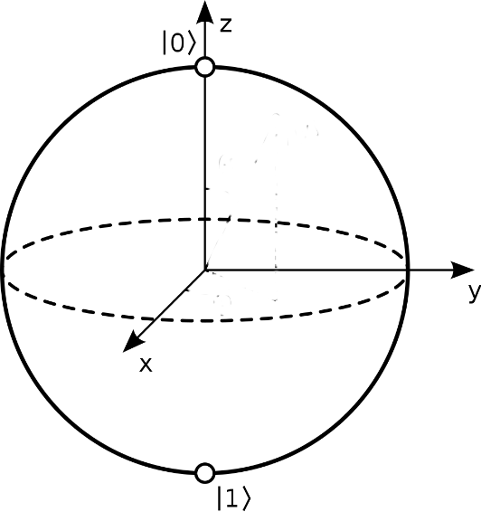
See the blue dot? What is the qubit value? | See the blue dot? What is the qubit value?

